**BEEE LAB EVALUATION**

**Exp. 2**

Design automatic led Diwali lights (consisting of 6 led’s) such that it only works during night and can generate two patterns which can be toggled with switch. a. Pattern 1 –led chaser b. Pattern 2 – even-odd led’s

**Circuit Diagram:**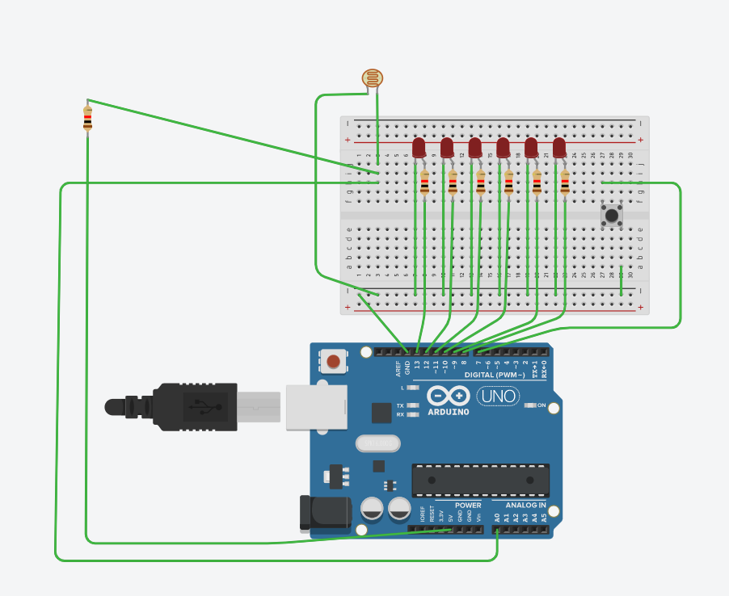

**Theory**

**Concept Used :**

In this Arduino circuit we are using the concept of LDR and Switch.

LED Chaser

**Apparatus Required :**

**1.**Arduino

**2.**Breadboard

**3.**Connecting Wires

**4.**LDR

**5.**Switch

**6.**Resistances

**7.** 6LEDs

**Learning & Observations:**

Arduino is a prototype platform (open-source) based on an easy-to-use hardware and software. It consists of a circuit board, which can be programed (referred to as a microcontroller) and a ready-made software called Arduino IDE (Integrated Development Environment), which is used to write and upload the computer code to the physical board.

The key features are −

* Arduino boards are able to read analog or digital input signals from different sensors and turn it into an output such as activating a motor, turning LED on/off, connect to the cloud and many other actions.
* You can control your board functions by sending a set of instructions to the microcontroller on the board via Arduino IDE (referred to as uploading software).
* Unlike most previous programmable circuit boards, Arduino does not need an extra piece of hardware (called a programmer) in order to load a new code onto the board. You can simply use a USB cable.
* Additionally, the Arduino IDE uses a simplified version of C++, making it easier to learn to program.
* Finally, Arduino provides a standard form factor that breaks the functions of the micro-controller into a more accessible package.

The **LDR** is a special type of resistor that allows higher voltages to pass through it (low resistance) whenever there is a high intensity of light, and passes a low voltage (high resistance) whenever it is dark.

The LDR gives out an analog voltage when connected to VCC (5V), which varies in magnitude in direct proportion to the input light intensity on it. That is, the greater the intensity of light, the greater the corresponding voltage from the LDR will be. Since the LDR gives out an analog voltage, it is connected to the analog input pin on the Arduino. The Arduino, with its built-in ADC (analog-to-digital converter), then converts the analog voltage (from 0-5V) into a digital value in the range of (0-1023). When there is sufficient light in its environment or on its surface, the converted digital values read from the LDR through the Arduino will be in the range of 800-1023.

**Problems & Troubleshooting**

* While connecting the wires one should check that whether the wires are connected on the right pin or not.

**Precautions**

**Note** − To find out the polarity of an LED, look at it closely. The shorter of the two legs, towards the flat edge of the bulb indicates the negative terminal.

* LED should be connected to the right pin and one should also check the polarity of Anode and Cathode while connecting to the breadboard.
* LDR should be used under certain light condition.

**Learning Outcomes**

Follow the circuit diagram and hook up the components on the breadboard as shown in the image given above.

An LED chaser is loosely defined as a system where LEDs follow one another in a certain pattern, so start go start designing!

Led Chaser is a circuit which blinks LEDs in a particular frequency and particular pattern so that it provides the effect of illusion, LED are moving. These LED chasers are used in decorative lighting. The *LEDs* lights one by one for a period of 1second and the cycle repeats giving the running light appearance.

**BEEE LAB CU**